Advanced Android Programming

Assignments

Assignment 1

Student: Oscar Blide

c8blos00
DIN18SP
Code in GitHub

OAMK
Assignment 1

1.
Explanation of these topics:
1. Object
2. Class
3. Instantiation of object (creating an object)
4. Visibility (public / private / protected)
5. Member datas / methods
6. Inheritance
7. Interface
8. Polymorphism
9. Overriding
10.Abstract classes

Object
Both Objects and Classes revolve like we have it in real life entities. The Object works as a superclass of every class. In the hierarchy of class, is the Objects the root.
public class Contact {
String name;
String lastname;
String phoneNumber;
public Contact(String name, String lastname, String phoneNumber) {
this.name = name;
this.lastname = lastname;
this.phoneNumber = phoneNumber;
}
}

Class
A Class in Java can be simplified as a user defined prototype or like a blueprint. The Class represents as a set of methods or it could be properties for all objects of one type. With the help of Java Virtual Machine can the Classes be constructed automatically and so on be loaded.
public class Contact {
String name;
String lastname;
String phoneNumber;
public Contact(String name, String lastname, String phoneNumber) {
this.name = name;
this.lastname = lastname;
this.phoneNumber = phoneNumber;
}
}

Instantiation of object (creating an object)
In an OOP creating instance of the object. With a name or by memory is described inside a class declaration.
FirstContact = new Contact("Sven", "Johansson","0709465345");
SecondContact = new Contact("Eva", "Lindgren","0709266447");
System.out.println("Name:"+FirstContact.getName());
System.out.println("Lastname:"+FirstContact.getLastname());
System.out.println("Phone:"+FirstContact.getPhoneNumber());

Visibility (public / private / protected)
The access of modification is the cornerstone of the difference between the visibility between public, private and protected. The public gives a bit more freedom and it’s the least restrictive one of them and the private is more the opposite. Private is a bit more restrictive. While the protected is between there.
public class Person {
public String name;
protected int age;
private int id;
}

Member datas / methods
Everything from names, id or salary that contains in a Class is data members (variables). Data members is just a verity of variables.
public class Person {
String name = "";
int age = 34;
int id = 011;
}

Inheritance
In an existing object by deriving a new object with behavior and properties that already exist in the previous object. Inherit it to the new or with other words extending it.
public class Animal {
String color;
public void eat() {}
}
public class Dog extends Animal {
String breed;
public void bark() {}
}
public class Cat extends Animal {
int age;
public void purr() {}
}

Interface
Between objects there is a communication provided from the interface and methods that is declared. From that interface. It’s works almost as a class, as a reference type. That can contain everything from static methods, default methods and method signatures.
<LinearLayout
android:id="@+id/linearLayout1"
android:layout_width="wrap_content"
android:layout_height="wrap_content"
android:orientation="horizontal"
android:layout_gravity="center"
>
<Button
android:id="@+id/add_button"
android:layout_width="wrap_content"
android:layout_height="wrap_content"
android:text="Add"
>
</Button>

<EditText
android:id="@+id/text_editor"
android:layout_width="match_parent"
android:layout_height="wrap_content"
android:hint="Add a country"
>
</EditText>

</LinearLayout>

Polymorphism
If an Object that passes several IS-A tests can be a sign of polymorphism. Any of them. The reason is that polymorphism is when an object that takes many forms or have the ability too.
Animal feed(Animal animalToFeed){
// Feed any animal here
return animalToFeed;
}

Overriding
Used to override a method declaration in the supertype by another method. If there is something missing in the code can it help with the override for the error to clearly generate a message.
public class MainActivity extends AppCompatActivity {
@Override
protected void onCreate(Bundle savedInstanceState) {
super.onCreate(savedInstanceState);
setContentView(R.id.activity_main);
TextView textView = findViewById(R.id.text_editor);
}
}

Abstract classes
With an abstract class must be Override in the derived class and “non” abstract always call the method from the Super class. That means that It can use any method by the method body or with function.
abstract class Cat {
String breed;
public void purr() {
System.out.println("Purr");
}
}
class ragdoll extends Cat {
}

2. Test UI
LinearLayout (vertical, horizontal), ConstraintLayout and CoordinatorLayout.

(Code in Github)
(Map: Lab_1_MoreUI)

3.
https://developer.android.com/guide/components/fundamentals
Answer to following questions:

- What programming languages you can use for Android app development?

Answer:
The languages that are used for Android app development is mainly Java, Kotlin and C++. There are also other so-called frameworks as React Native and Flutter (Using the language Dart) that translates to these main languages. But meant to easily work for both android and IOS.

- What is .apk file?

Answer:
APK or Android Package Kit as it stands for. It’s a file format that are used by Android to install and distribute their applications.

- How Android system runs apps?

Answer:
Every application gets an ID that are used for the system to detect for each app. With help of the ID it can run that specific application. As a multiuser Linux system, the Android system works as a different user for all the apps.

- Name four types of Android components. Describe each.

Answer:
The four main Android components are:
- Activities
Activities is that fills the screen. The things in the application. Could be one or multiple activities in one view.
- Services
Services is more independent and works in the background as a component. It has no interface and don’t have to be affected by the activity.
- Broadcast receivers
With the Broadcast receiver component can the application register for an event. When registered is reaching its end of lifecycle, sends a message to the receiver to notify. It can be implemented in the manifest file.
- Content providers
Access part of application data. The primarily thing is that other application can use the content providers. Bringing access to and can provide UI data. Good for companies that are working together.
Otherwise what they all have in common is that the elements need to be included in the manifest, inside the application project.

- What is manifest file and what is its purpose?
Answer:
Manifest file stores information that gives description of the application to Google Play, Android build tools and the Android operating system. It works almost as a guide to the project. Inside the manifest file is the name of the application. The views that are used. Every project must have a manifest file.

<application
android:allowBackup="true"
android:icon="@mipmap/ic_launcher"
android:label="@string/app_name"
android:roundIcon="@mipmap/ic_launcher_round"
android:supportsRtl="true"
android:theme="@style/AppTheme">
<activity android:name=".MainActivity">
<intent-filter>
<action android:name="android.intent.action.MAIN" />
<category android:name="android.intent.category.LAUNCHER" />
</intent-filter>
</activity>
</application>

- What are resources? Why they are needed?
Answer:
The resources contain the applications additional files as strings, styles, images, layouts definitions and images. This makes it easier to maintain when everything has its own place. Keeping the files cleaner and smaller. If something needs to be changed or added its quick to straight away jump into that file with no extra around it. With it can be easily accessed too in other locations in the application without rewrite the code.

- UI Hierarchies (Layouts)
(Code in Github)
(Map: Lab_2_1)
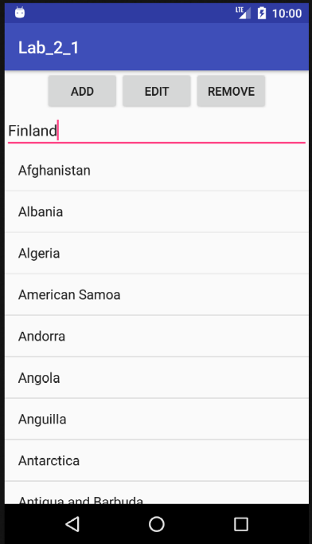

Assignment 2
LAB 2
(Code in Github)
(Map: Lab_2_2)
(Map: Lab_2_3)
(Map: Lab_2_4)
(Map: Lab_2_5)

Assignment 3
LAB 3
(Code in Github)
(Map: Lab_3_1)
(Map: Lab_3_2)
(Map: Lab_3_3)
(Map: Lab_3_4)

Assignment 4
LAB 4

